**LAB # 4**



**CSE-203L Circuit & Systems-II Lab**

**Fall 2022**

**Submitted by: Ali Asghar**

**Registration No.: 21PWCSE2059**

**Class Section: C**

“On my honor, as student of University of Engineering and Technology, I have neither given nor received unauthorized assistance on this academic work.”

Student Signature: ______________

Submitted to:

**Engr. Faiz Ullah**

8th November, 2022

Department of Computer Systems Engineering

University of Engineering and Technology, Peshawar

**TITLE:**

**Series R, L, C Circuits**

**OBJECTIVES:**

* To examine the voltage and current relationships in series R, L, C networks.
* To study the phase of the various components (like resistor, inductor and capacitor).
* To understand how Kirchhoff’s Voltage Law can be extended for AC circuits.

**APPARATUS:**

* Oscilloscope
* AC Function Generator

**COMPONENTS:**

* 1 nF Capacitor
* 10 mH Inductor
* 1k Ω Resistor

**THEORY OVERVIEW:**

Each element has a unique phase response: for resistors, the voltage is always in phase with the current, for capacitors the voltage always lags the current by 90 degrees, and for inductors the voltage always leads the current by 90 degrees. Consequently, a series combination of R, L, and C components will yield a complex impedance with a phase angle between +90 and -90 degrees. Due to the phase response, Kirchhoff’s Voltage Law must be computed using vector (phasor) sums rather than simply relying on the magnitudes. Indeed, all computations of this nature, such as a voltage divider, must be computed using vectors.

**RLC SERIES CIRCUIT:**

An RLC circuit is an [electrical circuit](https://en.wikipedia.org/wiki/Electrical_circuit) consisting of a [resistor](https://en.wikipedia.org/wiki/Electrical_resistance) (R), an [inductor](https://en.wikipedia.org/wiki/Inductor) (L), and a [capacitor](https://en.wikipedia.org/wiki/Capacitor) (C), connected in series. The name of the circuit is derived from the letters that are used to denote the constituent components of this circuit, where the sequence of the components may vary from RLC.

**RLC SERIES CIRCUIT DIAGRAM:**

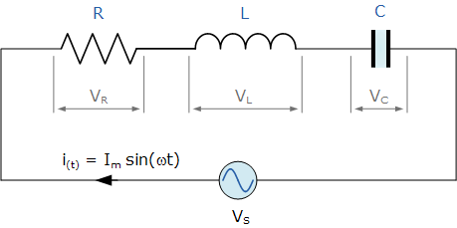

**impedance:**

The impedance of the circuit is the total opposition to the flow of current denoted by Z.

**MATHEMATICAL FORM:**

$Z= \sqrt{R^{2}+{(X_{L}-X_{c})}^{2}}$

**R = Resistance of the resistor**

**XL = Inductive Reactance of inductor**

**Xc = Capacitive Reactance of capacitor**

**CIRCUIT DIAGRAM:**

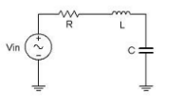

Figure 1

**PROCEDURE:**

1. Using Figure 1 with Vin=2Vp-p sine at 10 kHz, R=1kΩ, L=10mH and C=10nF, determine the theoretical inductive and capacitive reactance and circuit impedance, and record the results in Table 1 (the experimental portion of this table will be filled out in step 4). Using the voltage divider rule, compute the resistor, inductor and capacitor voltages and record them in Table 2.
2. Build the circuit of Figure 1 using R=1kΩ, L=10mH and C=10nF. Set the generator to a 10 kHz sine wave and 2 Vp-p. Using oscilloscope measure the signals. Unfortunately, it is impossible to see the voltages of all the three components simultaneously using only two probes of the oscilloscope. To obtain the proper readings, place one probe on the function generator to see the input signal and the second probe across the last element. This step is repeated three times. The first time the components are so arranged that capacitor is the last component, the second time inductor is connected as the last component and finally resistor is made the last component. The peak-topeak voltages and phase angles of each one of the three components, relative to the source are thus determined in turn. Thus Vs, VC, VL and VR are measured. Record in Table 2. 3.
3. Compute the deviations between the theoretical and experimental values of Table 2 and record the results in the final columns of this table.
4. Based on the experimental values, determine the experimental Z, XL and XC values via Ohm’s Law (i=VR/R, XL=VL/i, XC=VC/i, Z=Vin/i) and record back in Table 1 along with the deviations.
5. Create a phasor plot showing Vin, VL, VC, and VR.
6. Repeat the experiment for 1nF capacitor, 1mH inductor and 1kΩ resistor.

**OBSERVATIONS:**

For V(p-p) = 2V, f = 10KHz, R = 1kΩ, L = 10mH, C = 10 nF

**TABLE:1**

|  |  |  |  |
| --- | --- | --- | --- |
|  | Theoretical | Experimental | %Deviation |
| XC | 1591.55 | 1564.62 | 1.69% |
| XL | 658.32 | 680.27 | 3.22% |
| Z | 1388.46 | 1334.61 | 3.88% |
| ϴ | -43.9 | -41.98 | 4.37% |

**Ip-p = 1.4mA**

**TABLE:2**

|  |  |  |  |
| --- | --- | --- | --- |
|  | Theoretical | Experimental | %Deviation |
| VC | 2.29 V | 2.3 V | 0.43% |
| VL | 0.98 V | 1 V | 2% |
| VR | 1.4 V | 1.45 V | 3.45% |
| VS | 2 V | 2 V | 0% |
| ϴV | -43.95 | -42.5 | 3.2% |

**For VR:**

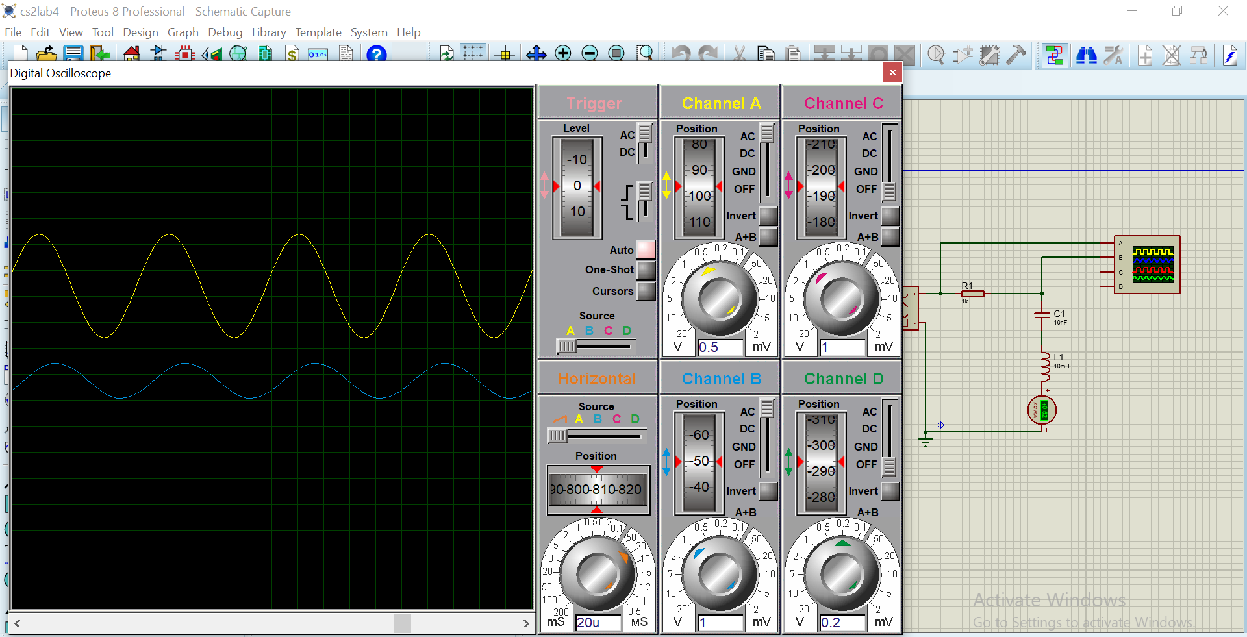

**For VC:**

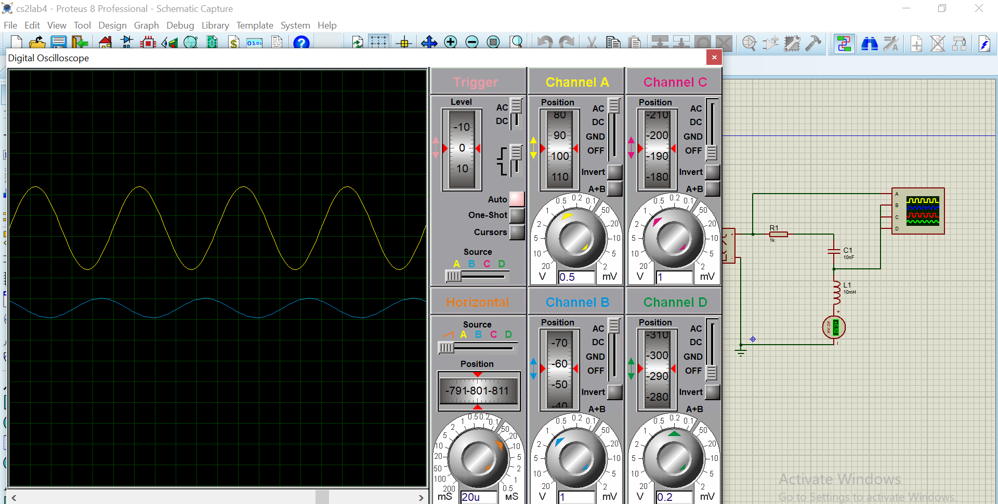

**For VL:**

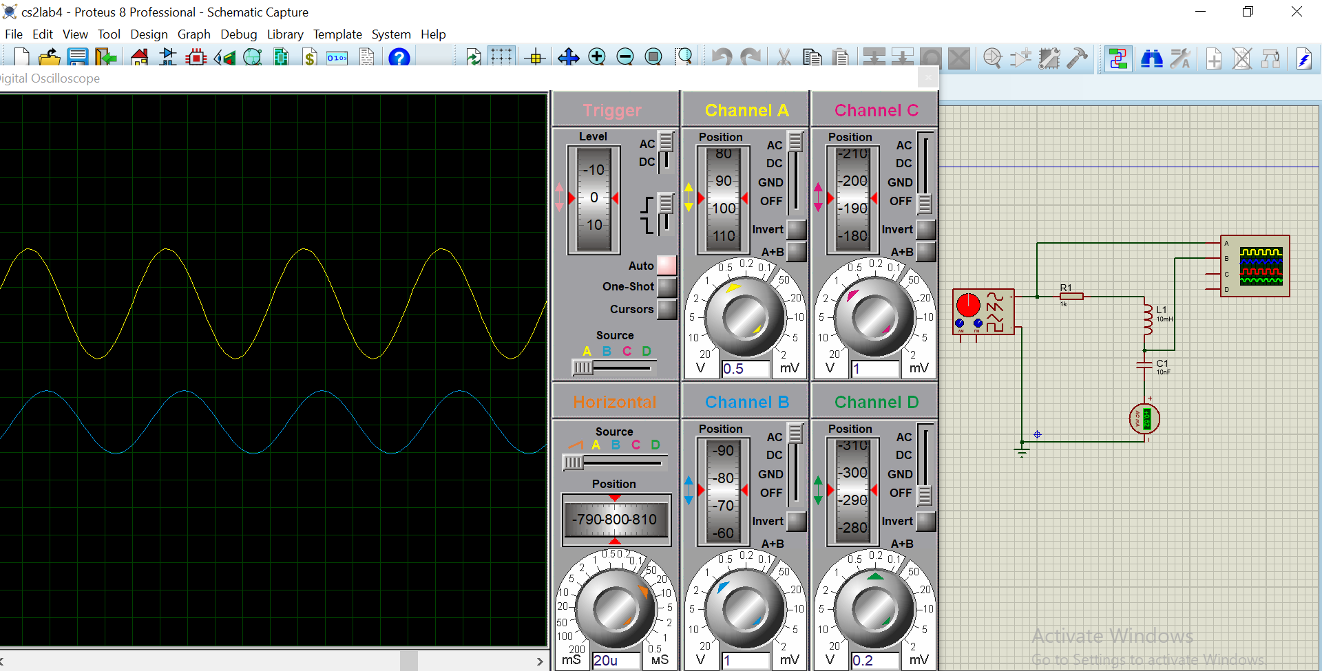

**QUESTIONS:**

**Question#1:**

What is the phase relationship between R, L, and C components in a series AC circuit?

**Answer:**

**Phase:**

When capacitors or inductors are involved in an AC circuit, the current and voltage do not peak at the same time.

***The fraction of a period difference between the peaks expressed in degrees is said to be the phase difference.***

* The phase difference is <=90 degrees.
* It is customary to use the angle by which the voltage leads the current.
* This leads to a positive phase for inductive circuits since current lags the voltage in an inductive circuit. The phase is negative for a capacitive circuit since the current leads the voltage.
* The useful mnemonic ELI the ICE man helps to remember the sign of the phase.
* The phase relation is often depicted graphically in a phaser diagram.

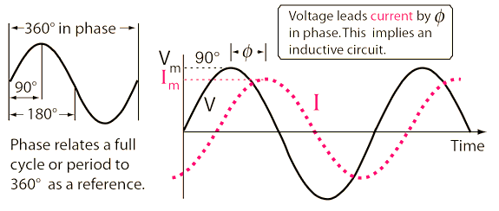

* It is sometimes helpful to treat the phase as if it defined a vector in a plane.
* The usual reference for zero phase is taken to be the positive x-axis and is associated with the resistor since the voltage and current associated with the resistor are in phase.
* The length of the phasor is proportional to the magnitude of the quantity represented, and its angle represents its phase relative to that of the current through the resistor.
* The phasor diagram for the RLC series circuit shows the main features.

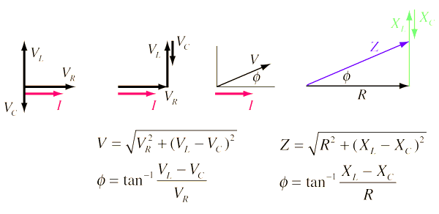

**ELI the ICE man**

* It is a mnemonic for the phase relationships of current and voltage.
* When a voltage is applied to an inductor, it resists the change in current.
* The current builds up slowly than the voltage, lagging in time and phase.
* Since the voltage on a capacitor is directly proportional to the charge on it, the current must lead the voltage in time and phase to conduct charge to the capacitor plates and raise the voltage.

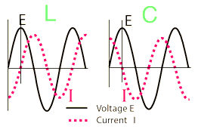

**Question#2:**

Based on measurements, does Kirchhoff’s Voltage Law apply to the tested circuits?

**Answer:**

* Current in a series RLC circuit is the same in amplitude and phase through all three components.
* The voltage drop across them is another matter. But they still add up.

For ELI the ICE man.

E, the symbol for voltage (not to be confused with V, the unit of volt) in an inductor L leads I, the symbol for current. ELI

I, the symbol for current, in a capacitor C leads E, the symbol for voltage. ICE

The "man" part is just to make the mnemonic easier to remember.

***So in a series RLC circuit, current is the reference.***

Let's consider a series RLC circuit at its resonant frequency. This is the frequency at which the amplitude of the reactance of the inductor and the capacitor are equal to each other.

* Across the resistor, voltage is in phase with the applied current.
* Across the inductor, voltage leads the applied current by 90 degrees.
* Across the capacitor, voltage lags the applied current by 90 degrees.

At the resonant frequency, the voltages developed across the capacitor and inductor are equal, but 180 degrees out of phase with each other.

So if you add up all the voltages, in phase Vr, -90 degree Vc, and 90 degree Vl, the voltages across the inductor and capacitor cancel and leave only the voltage across the resistor. Which equals the driving voltage.

***Hence, voltages around the loop still sum to zero.***

Kirchhoff's law is applicable to **RLC** circuits in any condition of the **RLC** parameters.  
The voltage equation can be directly written with the help of Kirchhoff voltage law.  
The sum of voltage drop in resistance, inductor and capacitor is equal to the input voltage v(t).  
Since our input is AC so all three components will work and experience a voltage drop accordingly.  
And thus Kirchhoff's is applicable to any existing actual electrical circuit

**Question#3:**

In general, how would the phasor diagram of Figure 1 change if the frequency was raised?

**Answer:**

As we know that in Inductive reactance, the reactance is directly related to the frequency. Also, in capacitive reactance, the reactance is inversely related to the frequency. If we increase the frequency, the inductive reactance increases whereas the capacitive reactance decreases.

So in impedance, the difference of inductive reactance and capacitive reactance increases which in-turn increases the impedance value.

So if the impedance is large, then the phase angle decreases because phase angle is inversely related to the impedance as shown below;

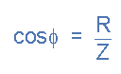

**Question#4:**

In general, how would the phasor diagram of Figure 1 change if the frequency was lowered?

**Answer:**

As we know that in Inductive reactance, the reactance is directly related to the frequency. Also, in capacitive reactance, the reactance is inversely related to the frequency. If we decrease the frequency, the inductive reactance decreases whereas the capacitive reactance increases.

So in impedance, the difference of inductive reactance and capacitive reactance decreases which in-turn decreases the impedance value.

So if the impedance is less, then the phase angle increases because phase angle is inversely related to the impedance as shown below;



**CONCLUSION:**

We conclude the following main points from this lab

* Inductive reactance is directly related to the frequency.
* Capacitive reactance is inversely related to the frequency. If we increase the frequency, the inductive reactance increases whereas the capacitive reactance decreases.
* If the impedance is large, then the phase angle decreases because phase angle is inversely related to the impedance.
* Kirchhoff's law is applicable to **RLC** circuits in any condition of the **RLC** parameters